RMCA Enjoys “Covered Bridges Tour”

All bridges crossed the Ashuelot River

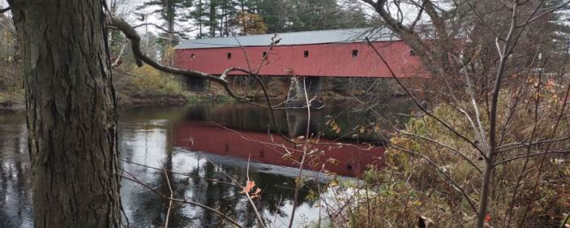

Crisson Covered Bridge in West Swanzey, NH

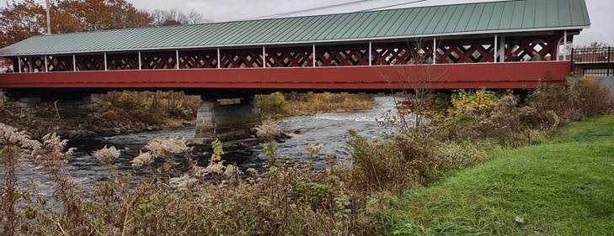

Thompson Covered Bridge in West Swanzey, NH

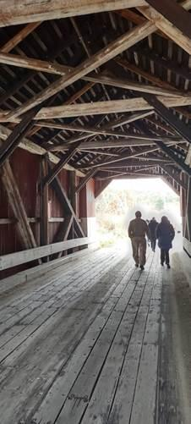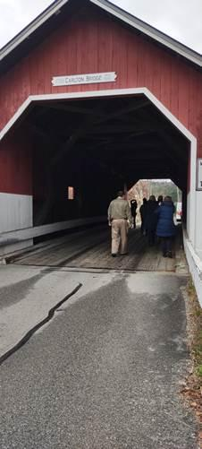

Thompson Covered Bridge in Swanzey Village, NH

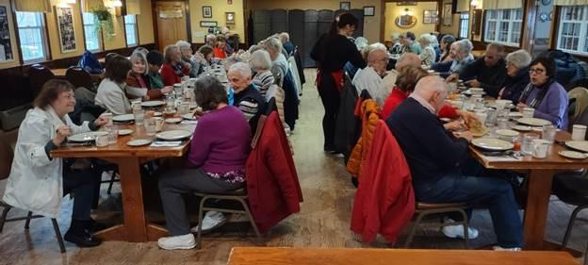

RMCA enjoying a luncheon at East Hill Farm in Troy NH